**Name _______________________________________ Date __________  
  
Directions: Choose the best unit   
to measure each capacity. Write   
gallons, pints, or fluid ounces.**

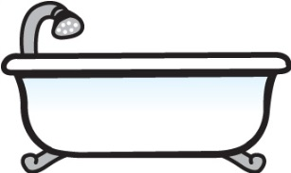

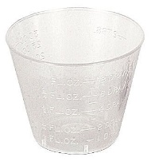

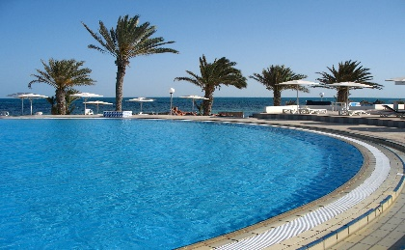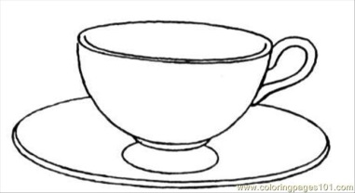**1.   
  
  
  
  
___Fluid Ounces___  
  
2.**

**____Gallons____**

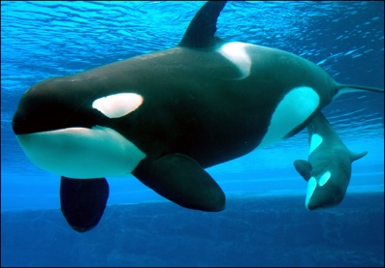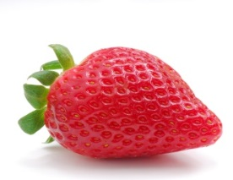 **Directions: For 3 and 4, what is the   
best unit of weight for these items?   
Write ounce, pound, or ton.  
  
  
3.**

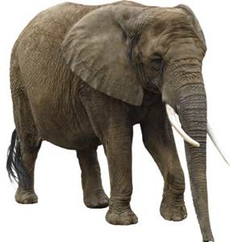 **_________Ton_________  
  
  
4.   
  
  
  
  
  
  
_______ounce_______**



**Convert each measurement for   
# 5 - 14**

5) 3 gal = ____48____ c

6) 18 ft = ____6______ yd

7) 9 lbs = ____144_____ oz

8) 3.5 cm = _____35______ mm

9) 22 fl oz = ___2__ c __6__ fl oz

10) 43 ft. = ___14__ yd ___1___ ft

11) 0.00078 g = ___0.78______mg

12) 3.72 m = _____0.00372_____km

13) 4.5 mm =_____0.0045______m  
  
  
14) .348 km = ____34800_______cm

**Directions: Find the start time**

15. End 3:35 A.M.

Elapsed 2 h 35 min

_______1 A.M.____________

16. End 1:26 P.M.

Elapsed 11 h 26 min

**________2 A.M._____________**

**Directions: For #17-19 look at each**

**pair of time. Write how much time**

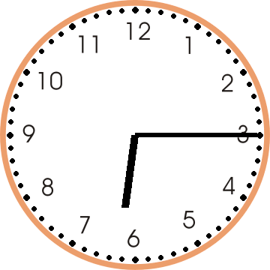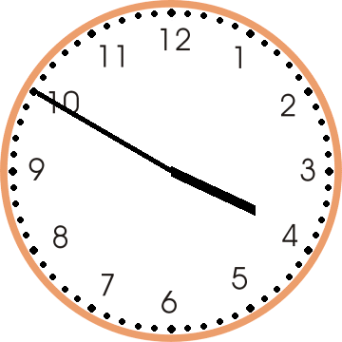**has passed.  
  
17.**  
  
 **______2h 25m_______**

18. Start at 7:50 A.M. End 4:35 P.M.

_______8h 45m__________

19. Start at 6:19 A.M. End 11:00 A.M.

_________4h 41m____________

**Directions: solve the problem**

20. In fourth grade Jack the giant was 3 feet 11 inches tall. Now he is 7 feet 5 inches tall. How much did he grow?

_______3ft 6in___________

21. A snake was 4 feet 2 inches long when it was a baby. It grows another 3 feet 7 inches in a year. How long is it now?

________7ft 9in__________

**22. 27 ft. 11 in.**

**+ 10 ft. 4 in.  
 38 ft 3 in**

**23. 22 yd. 2 ft.  
 - 17 yd. 1 ft.**

5 yd 1 ft  
  
  
  
  
  
**24. 5 gal 2 qt**

**- 3 gal 3 qt  
 1 gal 3qt**

**Directions: Use the Movie Schedule to answer questions 25-26.**

**Show your work in the box. (2 points each).**

  
25-26. Mr. Jones went to the second showing of The Haunted Castle. The movie has a running time of 104 minutes. At what time did the movie end?

|  |
| --- |
| 1 h 44 m  Answer: 7:59 pm  6:15pm |

The blizzard started at 3 A.M. The snow accumulated 1½ inches the first hour and 2½ inches each hour after that for the next 12 hours. How much snow was on the ground at 8am? Make a table to help you answer the question.

|  |  |
| --- | --- |
| Hour | Snow Accumulation |
| 3 | 0 |
| 4 | 1.5 |
| 5 | 4 |
| 6 | 6.5 |
| 7 | 9 |
| 8 | 11.5 |
|  |  |